

**Online Mobile Shop System**

# Assignment Details

This project is about an e commerce system for an  
online mobile phone shop where sellers that  
have been registered on our system can sell mobile phones to the buyers  
who are also registered to our system. This Document includes   
details regarding designs, management and handling of this project

## Team Members

IT17005586 – A.D St.John  
IT16058156- Rukshan Akalanka  
IT15122292-H.W.P.K.C Siriwardhana  
IT17085540-Lakshan Madushanka

# Member Details

Student ID:- IT17085540

Name:- Lakshan Madushanka

**Project Workload**:-

Created a Web Service for shipping products

Student ID:-IT15122292

Name:-Chaminda Siriwardhana

**Project Workload**: -

Created a Web Service to store product details inclusive of update and delete operations with the aid of GUI.

Student ID:- IT17005586

Name:- Angello Dushantha St.John

**Project Workload**:-

Create Web Service for placing customer orders, including deleting and updating.

Student ID:- IT16058156

Name:- Don Rukshan Akalanka Kumarage

**Project Workload**:-

Create a web services for user management services for seller and buyers. (logging, registration etc …)

## **Github Repository**

<https://github.com/Angello456/Online-Mobile-Store.git>

# Software Development Methodology

When starting this project our team had to face some unavoidable problems, such as delaying project work due to unavoidable circumstances. Therefore our team had to come up with a good software engineering methodology that can accelerate the development process as well as can provide good quality results. So for a quicker development and for a higher quality product, using RAD(Rapid Application Development) Methodology was the best choice for the team.

### Rapid Application Development Methodology (RAD)

RAD Methodology is a condensed development process that is able provide quicker development with higher quality products. The main purpose of this methodology is to accelerate the entire development process with low investment costs. This allows active user participation which makes achieving the target easy. This encourages to take feedback which always provides scope improvement for any software development project.

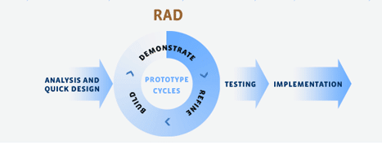

Onion Diagram

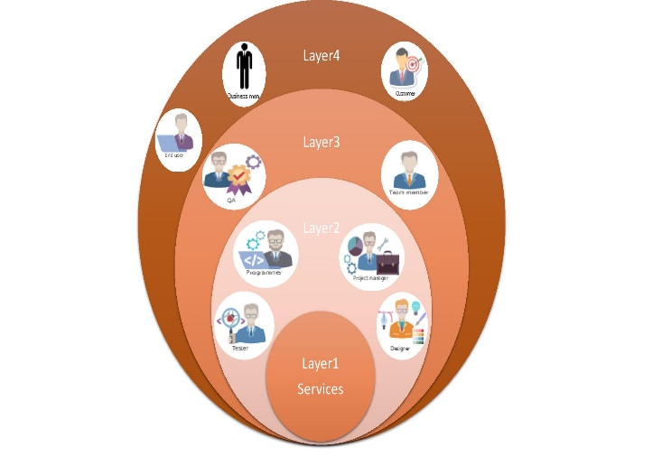

## Requirement Analysis

To start this project and create web services we had to find requirements that a user can be looking for when using an online mobile shop. So we came up with user stories for each web service and found functional and non-functional requirements.

Functional Requirements

Seller need to insert, update and remove products

Seller need to maintain an account

Buyer need to buy new products

Buyer need to register in to the system

Buyer need to manage his orders

Buyer need to checkout his order and use shipping service

Non-Functional Requirements

User friendliness of the services

Portability of the apis’

Maintainability

Security

Technical Requirements

When looking for technologies to build these services, what our team wanted was technologies that are more user-friendly and up to date with industry standards. After searching through technologies, some of the new technologies such as **Spring boot, Hibernate, Rest** and **JPA** have been selected to start the project.

## Use Case Diagram

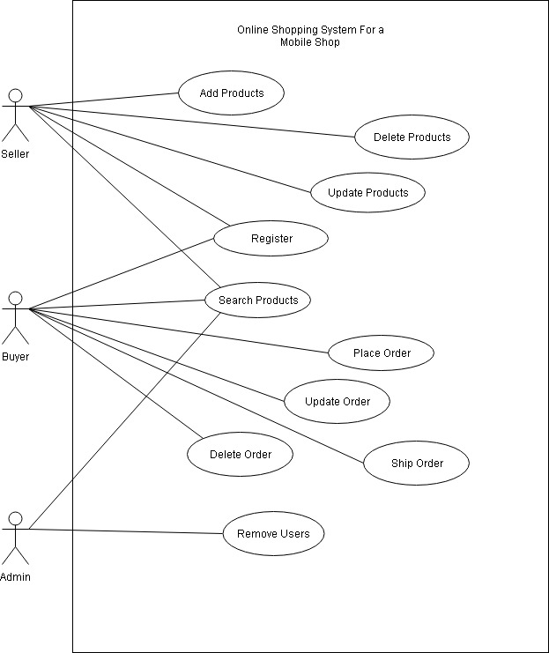

## Class Diagram

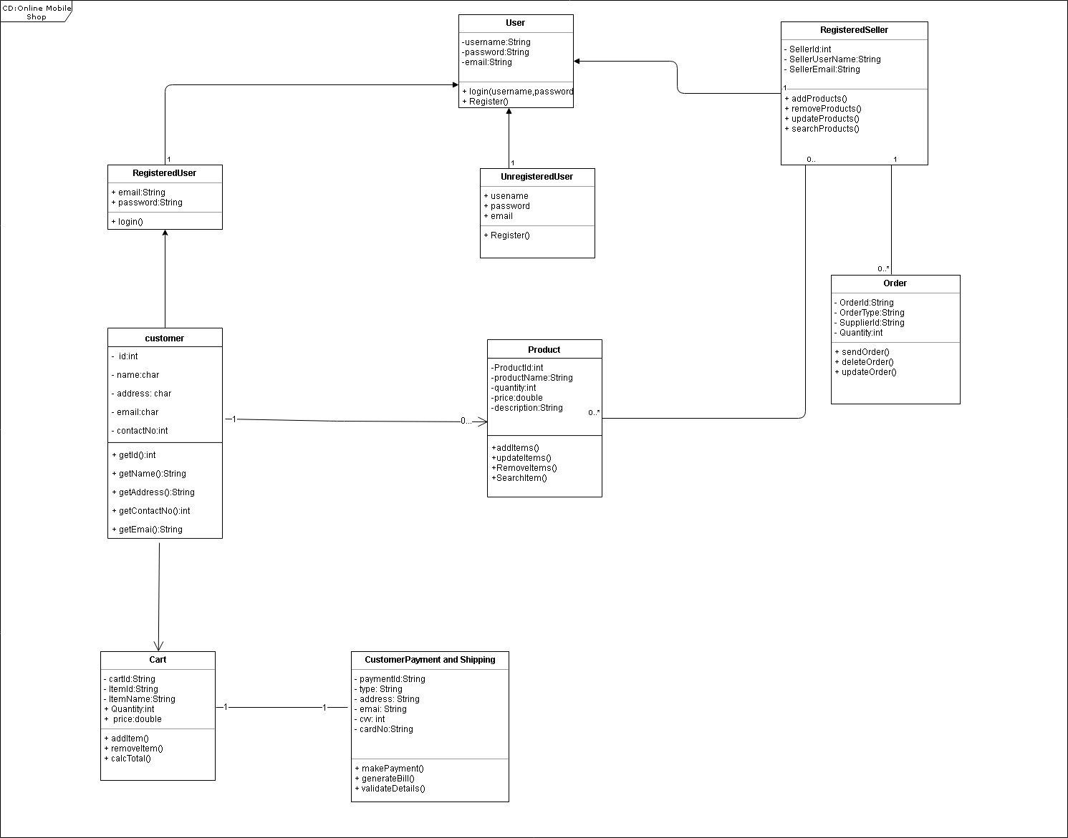

## Gantt Chart

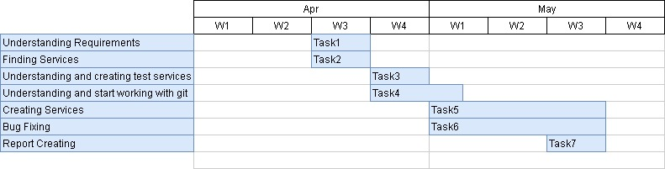

----END----